2. **Serene Escape 🌊**

One of our members has found a place so serene that they practically live there. Your mission is to uncover the name of the dam associated with this tranquil reservoir

Image:

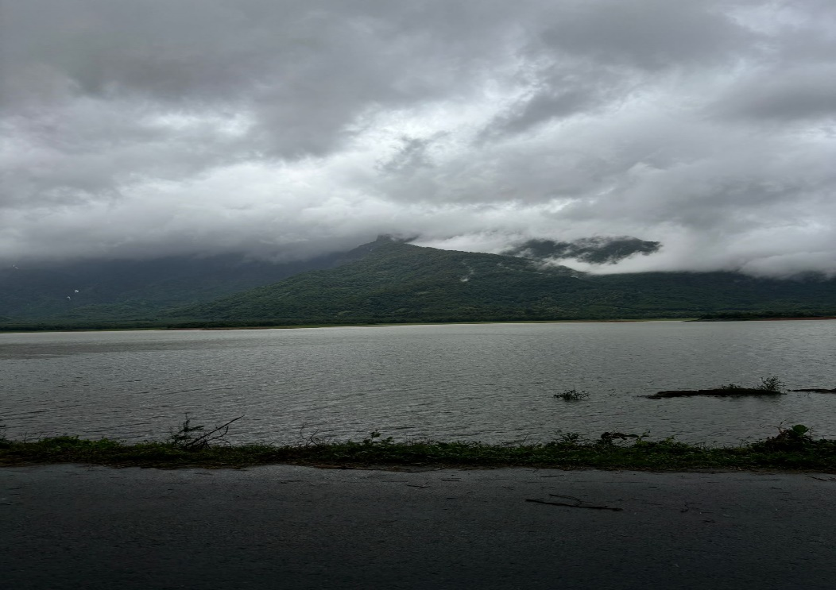

**Solution: Malampuzha Dam (Location: Palakkad, Kerala, India)**

**Approach:**

**1.Location Identification using Pincart AI**:

**Pincart AI**, a sophisticated image recognition tool, was used to analyze the geographical details in the uploaded photo. The AI tool processes visual data like landscape features, landmarks, and environmental patterns to deduce the likely location of the photo.

Through Pincart AI's analysis, the dam's approximate geographic coordinates or vicinity were identified as **Palakkad, Kerala, India**.

**2.Reverse Image Search**:

With the location data in hand, a **reverse image search** was conducted. This technique involves uploading the image to platforms like **Google Images** or specialized tools that compare it to a database of similar images on the internet.

The search results aligned with images of the **Malampuzha Dam**, a well-known reservoir and tourist attraction in **Palakkad**, confirming the dam in the image.